**6-1 Coding Assignment: Modifying Vulnerability Reporting**

**Eric Galtieri**

[Link to dependency check before modification.](C:\\Users\\erica\\OneDrive\\Desktop\\School\\dependency-check-report Before suppression.html)

[Link to dependency check after modification.](C://Users/erica/OneDrive/Desktop/School/dependency-check-report%20After%20suppression.html)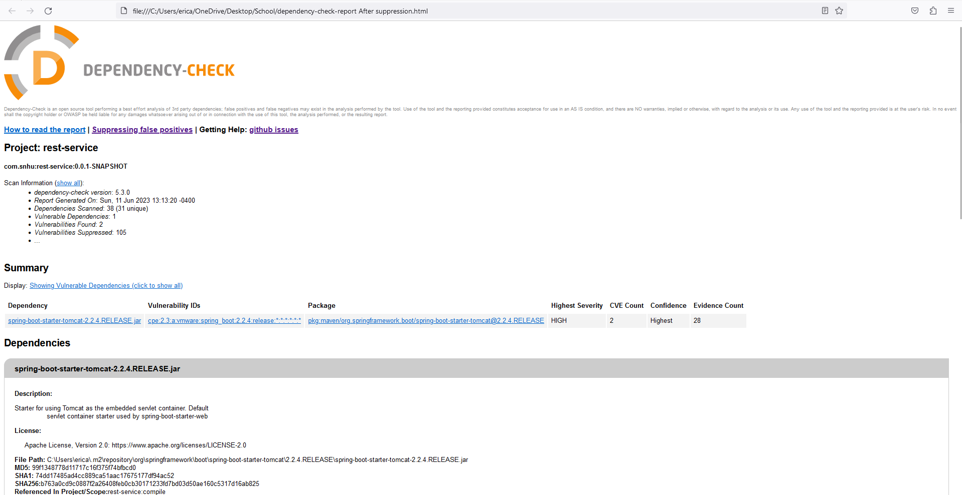

References:

file:///C:/Users/erica/OneDrive/Desktop/School/dependency-check- report%20Before%20suppression.html\

[file:///C:/Users/erica/OneDrive/Desktop/School/dependency-check-report%20After%20suppression.html](C://Users/erica/OneDrive/Desktop/School/dependency-check-report%20After%20suppression.html)